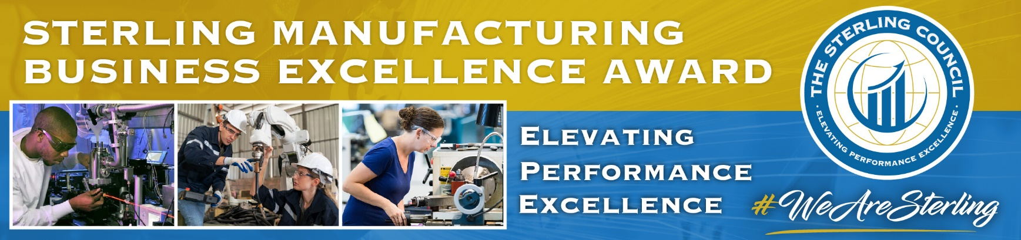
Sterling Manufacturing Business Excellence (SMBE) Award Process - 2023

This process and award bring focus on Florida manufacturing performance excellence. Manufacturers are interviewed and evaluated by expert teams of individuals from the manufacturing and Sterling communities who contribute time, expertise, and diverse perspectives in company evaluations.

The purposes of this award process are to:
- Recognize high-performing Florida manufacturing companies.
- Provide opportunities for organizational learning and development.
- Promote and elevate participating manufacturers and the Florida manufacturing sector.

- The process begins with nominations of manufacturers. Eligibility: All manufacturers with production facilities in Florida, not having won the Gold Level award in 2021 or 2022, are eligible to participate. It is not necessary for the nominee to be a member of any association. A nomination may be made by any individual or organization including any industry group, supplier, customer, workforce or economic development organization, University/College/School, or government agency. Self-nominations are also acceptable.
- Company commitment: A nominal fee investment for this award process with other promotional benefits is based on number of employees (FTEs) according to this schedule:
* $ 975 – fewer than 21
* $ 2075 – 21 to 50
* $ 3175 – 51 to 100
* $ 4275 – 101 to 150
* $ 5475 – More than 150
Time investment by the nominated manufacturing company is about six to eight hours over several days between mid-January and early-April 2023.
- To nominate, use the online Nomination Form or send an email to SMBEA@TheSterlingCouncil.org. Simply, please include your contact information as well as a name and contact information for the nominee company. No nomination write-ups are required.
- Following nomination, the Nominee will be notified and asked to complete (one to two hours) and submit the Application Profile and Overview and forward with attachments to SMBEA@TheSterlingCouncil.org. The writing style and the content of the Profile are not evaluated. The Profile provides context for evaluation, detailing information of the company, and describes internal and external pressures and influences which affect operations.

The final day for nominations is Friday, February 3, 2023. The Profile and Overview should be submitted by Friday, February 10, 2023.

- Once the Profile is submitted, an initial web meeting is scheduled with the Nominee and a team of Examiners for an overview (about 90 minutes) of the nominated company business. Discussion will include review of basic elements of high performance based on the Evaluation Criteria. Then the Examiner team will schedule and conduct a more in-depth interview (about three hours) with managers and employees to discuss detailed aspects of the manufacturer to evaluate company systems and practices.

- Upon completion of all company interviews, Examiners confer to review the evaluations, and select and recommend Finalists. A team of Judges will review the recommended Finalist evaluations and decide the winners. Awards will be made based on scoring against the 2023 Evaluation Criteria for high performance. Finalists and Winners will be recognized June 2, 2023 at the Hyatt Regency Orlando.

- All Finalists and Winners will be provided with a highly value-added evaluation feedback discussion and report offering specific identified company strengths and opportunities for improvement. Discussion will include recommended improvement actions and examples of role model practices. Afterwards, Finalists and Winners should also expect to be invited to participate in knowledge sharing and developmental activities in the Florida manufacturing community.

