Sterling Organizational Profile
Leadership Series

Organizational Profile
Key Factors Worksheet

Creating your own Organizational Profile

February 2022

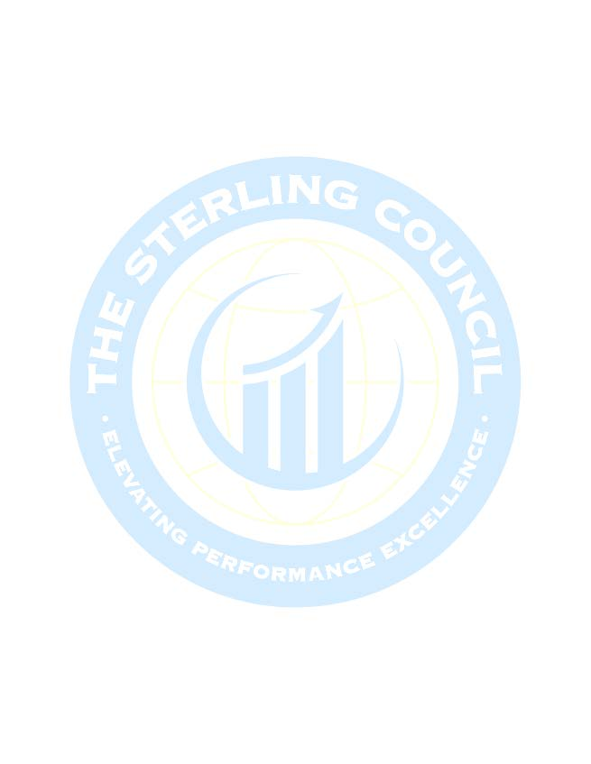

Organizational Profile

P1 Organizational Description: What are your key organizational characteristics?

P1a Organizational Environment

P.1a(1) Product and Services Offerings
- Main Product and Service Offerings? – may be programs, projects or services

- Relative Importance of each to your SUCCESS? – are they equal? are there priorities?

- Mechanisms for delivery – direct or indirect

P.1a(2) Mission, Vision and Values and Culture
- Your Mission – may also be Purpose – Why you exist

- Your Vision – Where do you see the organization in the future. Inspires the organization – guides the setting of values

- Your Values – part of your organization's culture i.e., shared beliefs, norms that contribute to the uniqueness of the environment

- Characteristics of your Organizational Culture, if any

- Organization’s Core Competencies, and relative importance to your mission. Core Competencies are your organization’s greatest expertise – strategically important capabilities that are central to fulfilling your mission. May involve technological expertise, unique service offering, marketplace niche

P.1a(3) Workforce Profile
- What is your Workforce Profile, including any recent changes in composition or needs

- Segments and employee groups – unique requirements for each, education, training, etc.

- Key Drivers for Engagement

- Any Collective Bargaining units

- Any Special Health and Safety Requirements

Page - 1

P.1a(4) Assets
What are your;
- Major facilities

- Equipment

- Technologies

- And intellectual property

P.1a(5) Regulatory Environment
What are your KEY;
- Occupational Health and Safety Regulations

- Accreditations

- Certifications or Registration Requirements

- Sector Industrial Standards

- Environmental, Financial and Product Regulations

Page - 2

P1b Organizational Relationships

P.1b(1) Organizational Structure
- Leadership and Governance Structure

- What Structures and mechanisms make up the Leadership System

- Reporting relationships;
  - Among the governance board

  - Senior Leaders

  - Parent Organization

P.1b(2) Customers and Stakeholders
- Key Market Segments

- Key Customer Groups

- Key Stakeholder Groups

- What are Key Requirements and Expectations for your customer support services, and operations including differences amongst the groups

P.1b(3) Suppliers, Partners and Collaborators
- Key Suppliers

- Key Partners

- Key Collaborators

- Role in Producing and Delivering Your Customer Support Services and enhancing your competitiveness

- Role in implementing innovations

- What are your Key Supply-Network requirements?

Page - 3
P2 Organizational Situation: What is your organization’s strategic situation?

P.2(a) Competitive Environment

- Competitive Position – relative size and growth, how many and what types of competitors do you have?

- Competitive Changes – what key changes affect your competitive situation, including changes that create opportunity for Innovation and collaboration?

- Comparative Data – Key sources of comparative and competitive data from within (and outside) your sector. What limitations affect your ability to obtain these data

P.2(b) Strategic Context
- What are your KEY Strategic Challenges?

- What are your KEY Strategic Advantages?

P.2(c) Performance Improvement System
- What is your Performance Improvement System - overarching systems approach might include Lean Enterprise system, Six Sigma Methodology, PDCA, decision science or employing other improvement tools.

- What are your PROCESSES for Evaluation and Improvement of key Organizational Projects and Processes?

File also available at: www.floridasterling.com

Page - 4

